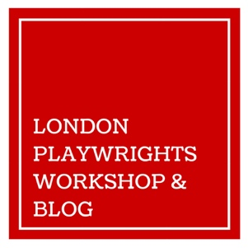
LONDON PLAYWRIGHTS WORKSHOP
EQUAL OPPORTUNITIES MONITORING FORM
DARK HORSE FESTIVAL 2016

If you prefer not to answer any of the following questions, please leave them blank.
Gender:

Age (in years):

What do you consider to be your ethnic group?

(eg. Chinese British, Black British, Asian English, White European, White American, Black, or I decline to answer)

Do you consider yourself to have a disability?

(if yes, please explain)

The Disability Discrimination Act defines disability as a physical or mental impairment which has substantial and long term adverse effect on the individual’s ability to carry out normal day-to-day activities.

How did you find out about this opportunity? (Blog, Twitter, Word of mouth, etc.)

